Supplier Quality

DFSS Six Sigma Capstone Project

Final Report

Janine White

5/7/2018

Contents

Define 2

Business Case 2

Scope 2

SIPOC 3

Problem/Opportunity Statement 3

Critical Customer Requirements 4

Define Phase Process 5

Measurement 5

Analysis 6

Figure 1. Supplier Quality Management Process Flow 7

Design 8

Validation 9

# Define

## Business Case

Founded in 2015, the company is a construction technology company striving to vertically integrate all services and sourcing associated with affordable multifamily housing in the United States, using standardized parts purchased from suppliers and manufactured in its factories to create elegant, sustainable and customized buildings in a process that is more like manufacturing than traditional construction projects. The company is striving to be a disruptor in the multi-trillion-dollar construction industry by translating building designs into manufacturable assemblies. Direct external customers are established development companies. Company offices are in California, Arizona, and Shenzen, China. The factory is in Arizona and is ISO certified. Products are sourced globally and shipped to the factory and job sites. Initially focused on multifamily housing, the company is branching out into single family houses and commercial construction. As a startup, the company just received over one billion dollars in the latest round of financing.

Consistent quality control is central to being able to complete standardized construction projects better, faster and cheaper. After Design selects a potential product for inclusion in construction, Product Managers contact Global Category Management (GCM) to find suppliers that can provide the products for the company at the best possible price in a reliable and ethical manner. GCMs prequalify suppliers and establish a Material Service Agreement (MSA), then refer the suppliers and products to Supplier Quality Management (SQM). When the company is creating new products, Product Managers come directly to SQM for benchmarking services and an initial assessment of what will be needed for product qualification. SQM is responsible for qualifying suppliers and products for purchasing based on risk management criteria, including design requirements, building codes, government standards and industry standards, and disqualifying them if they fail to deliver in quality manner. The SQM has two teams. The Scottsdale, Arizona, office is responsible for suppliers in the Americas and Europe, and the Shenzhen, China, office is responsible for Asia suppliers.

## Scope

This project was developed to create a data collection and analysis system for SQM that would provide daily insight into supplier quality risks, including products and purchasing, and reporting capabilities for monthly and quarterly reporting to executive management. Supplier Quality Management is a separate organizational structure from other quality organizations in the company, including Global Corporate Quality and Factory Quality. We interact with other quality organizations, for example, for ISO certification and resolving product complaints from the Factory, but they are currently mostly separate. In the future, they may be unified in a single quality system, but this project focused on supplier quality. Factory inspectors and engineers were given data entry and view privileges for inspection protocols completed in the factory, and Global Corporate Quality was given view access to data collection and reports as needed for audits.

Data collection was completed for Americas quality assessments and analyses were based on 2017 data. Validation was completed using 2018 data and Asia data collection is being phased in. Social and Environmental Responsibility (SER) is considered when selecting suppliers, but an SER team is being developed to specialize in SER assessment, so SER risk assessment was out of scope for this project. Finance is out of scope for this project, except that the minimum amount of testing needed to verify supplier and product quality should be conducted to minimize costs. Product delivery is not controlled by SQM, but the history of a supplier’s performance is relevant.

## SIPOC

|  |  |  |  |  |
| --- | --- | --- | --- | --- |
| **Supplier** | **Input** | **Process** | **Output** | **Customer** |
| * Developer * Product Manager * GCM * SQM * Supplier | * Supplier * Products * Competitor benchmarks * Supplier product data * Supplier delivery history   Requirements   * Design Requirements * Government codes & regulations * Industry standards |  | * Third-party product test reports * Supplier qualification * Product qualification * Housing component * Purchase Orders * Shipments * Building * Customer satisfaction   Requirements   * Supplier Standards * Product Standards | * Developer * Supplier * Product Manager * Buyer * GCM * IQC * Factory * Job Site * Building Manager * Renter |

## Problem/Opportunity Statement

The construction industry is rarely quality management oriented, allowing a lot of rework throughout the construction process and focusing primarily on passing inspections as gate keeping. The company’s SQM process is changing rapidly and struggling to be integrated with other systems. At the beginning of the project, twenty-two Product Qualification Tests (PQTs) and Product Inspection Protocols (PIPs) had been developed for over two hundred product categories and fifty-seven of 5000 products had been fully qualified. PIPs are subsets of the PQTs that can be easily completed at supplier factories before shipment or on the factory floor when products arrive. Suppliers provide various levels of cooperation with the Supplier On-Site Assessment (SOSA). Purchase Orders (POs) are regularly being placed from suppliers that have not had a SOSA to evaluate the supplier’s quality systems, and for products that have not had a PQT completed. Incoming Quality Control (IQC) at the factory had just been formed with an Operational SQM as lead and two inspectors. Quality assessments were stored as Microsoft Word documents in cloud services and the data was not regularly collected and analyzed on the quality assessments that were completed beyond counting how many assessments were completed and how many failed.

Although the Asia and Americas teams work together in many cases, they follow different processes. The Americas team approximately doubled in the last quarter of 2017. US human resources and travel are more expensive, and have many more suppliers per resource. Asia products are qualified using test protocols developed by a third-party testing service, while Americas products are qualified using PQTs developed by Requirements SQMs. Although SOSAs, First Article Inspections (FAIs) and Pre-Shipment Inspections (PSIs) are completed for all Asia suppliers, Americas suppliers are primarily judged using SOSAs, PQTs, and PIPs. A unified process would simplify operations and risk assessments are needed to determine when suppliers warrant additional or ongoing scrutiny.

## Critical Customer Requirements

Customer (Developer, Building Manager and Renter), Builder and Supplier needs concerning building components and construction both overlap and are in competition:



Critical Customer Requirements (CCRs) are:

* Products must be safe.
* Products must meet design and functionality requirements.
* Products must be able to be used in the manufacturing process or installed on the job site.
* Products delivered must match product specifications and Purchase Order.
* Product delivery times must be consistent and as short as feasible.
* Product testing costs and time must be minimized to enable manufactured components and buildings to be delivered as cheaply and quickly as possible.

Note that although the customer may have brand preferences, the customer typically doesn’t directly care about the supplier, except as the finished product or building is able to meet or exceed CCRs.

## Define Phase Process

I discussed the SQM process with SQM team members and the SQM Director, who was particularly interested in risk assessments to evaluate when quality assessments are needed, as well as GCMs, Product Managers and Risk Management. I created a high-level process map, and SIPOC, and held a meeting to review the documentation, solicit involvement in the project, and establish a timeline. The primary participants were the Americas SQM team members, including the SQM Director, Operational SQMs, and Requirements SQMs. I drafted a project charter document with milestones based on DMADV that I reviewed with the SQM team and was approved by the SQM Director.

As supplier quality managers, discussions of who are our customers and what makes quality meaningful are an almost daily occurrence. We literally work closely together with GCMs and Product Managers, so, it’s often not necessary to have a separate meeting. Initially, I did not include an explicit CCR section. This was an oversight that I corrected by discussing customer needs and reviewing our detailed process flow with our direct customers, GCMs and Product Managers, who have contact with external customers and choose or develop products, and the Operational SQMs who have regular direct contact with suppliers. I summarized the customer needs and requirements, then held a meeting to review the documentation with the project team again to validate that the customer needs and requirements had been captured appropriately.

# Measurement

I researched supplier quality measurement in general and construction supplier quality measurement, as well as finding and reviewing all company quality procedure documentation available in the enterprise document repository used for ISO documentation. I created a detailed process flow of our supplier quality process including input and output indicators. I compiled all the measurement documentation in one document with a measurement system analysis of supplier, product, and purchase order data that included a glossary of operational definitions and related documents, definitions of key data fields, data collection plans and a baseline performance description. I held two meetings to review the document with the Americas and Asia SQM teams, including the Director.

I worked with IT to determine where existing data could be extracted and the available enterprise licensed systems that could be used for data collection, SharePoint, Smartsheet, or cloud shared Excel spreadsheets or an Access database. I asked the team which of those they were familiar with and evaluated the features of each system. Although Smartsheet is not well known, it is used extensively in the company and has the capability to generate forms for data entry. I would have preferred a solution using Microsoft Access and SharePoint because it is a relational database with forms and data validation capability, but Access support has recently been deprecated in Office365 and related applications. I reviewed the results with the SQM Director and finalized which systems would be used for data collection and analysis. I created a data collection system in Smartsheet with custom forms for each assessment type and product category to collect the agreed upon data fields. I created procedural documentation for data entry and held a training for the Americas team, who followed up by entering the historical Americas data and continued to enter supplier and product assessments as they were generated. When the Incoming Quality Control (IQC) team was formed, I created custom data entry forms for inspections and trained the IQC lead and inspectors on data entry. I later held a training meeting with the Asia team, who is working on entering their data now. Because of their feedback, I added dropdown lists for supplier names and IDs in quality assessment forms, although it added more work for me because the dropdown lists in Smartsheet only accept text lists.

Challenges related to measurement included ensuring that the meaning of automated data fields was understood, and ensuring that data was entered accurately and fully. There were many intricacies to the way that automated data can be compiled and reported. For example, Statistics Date and Delivery Date refer to the dates that the buyer would like to be delivered and the date that the supplier has agreed to deliver products, while the date that a product has been delivered is sometimes stored in a text field and as a delivered flag, making the available date calculation an expectation calculation, rather than the number days a shipment was delivered late. Also, different sources of information have different identifiers. The suppliers and products are identified differently between the system that maintains supplier and product documentation and the system used to place purchase orders, and purchase orders are placed from suppliers and for products that have not been qualified or fully documented. While Smartsheet provides a convenient data collection platform, it does not provide input verification. Daily data cleaning is required to ensure that all the data sources can be analyzed together as accurately as possible.

Another challenge is that failure data is very sparse due to prequalification and supplier controls. This is desirable from a business perspective, but it makes it difficult to statistically predict failure given limited data in a startup environment. The SQM team agreed that for the first round of development, risk ratings would be limited to a 0 to 3 scale and assessed together as low, medium and high risk. As more assessment data is collected and automated data connections become available, more granular modeling will be implemented. We also decided how missing data was to be treated for each risk rating, for example, what risk ratings should be assigned for suppliers that have not received specific assessments. Initially, the SQM Director wanted to rate missing data as riskier than disqualification, but in discussing this with the team, this was reversed.

# Analysis

I obtained permission to purchase JMP for data analysis. After the 2017 Americas data was entered, I analyzed the distributions and correlations of our data fields to determine variation in the data, create the risk rating scales, and identify opportunities for eliminating data collection. For example, some SOSA questions are highly correlated. We decided not to change the questionnaire until after the Asia data has been entered and analyzed, but noted questions that are likely to be redundant or not consistently rated. Limits and control charts for risk ratings were also determined. The data tends to be skewed or exponential because the suppliers are prequalified and we use assessments to further restrict the population being analyzed.

Figure 1. Supplier Quality Management Process Flow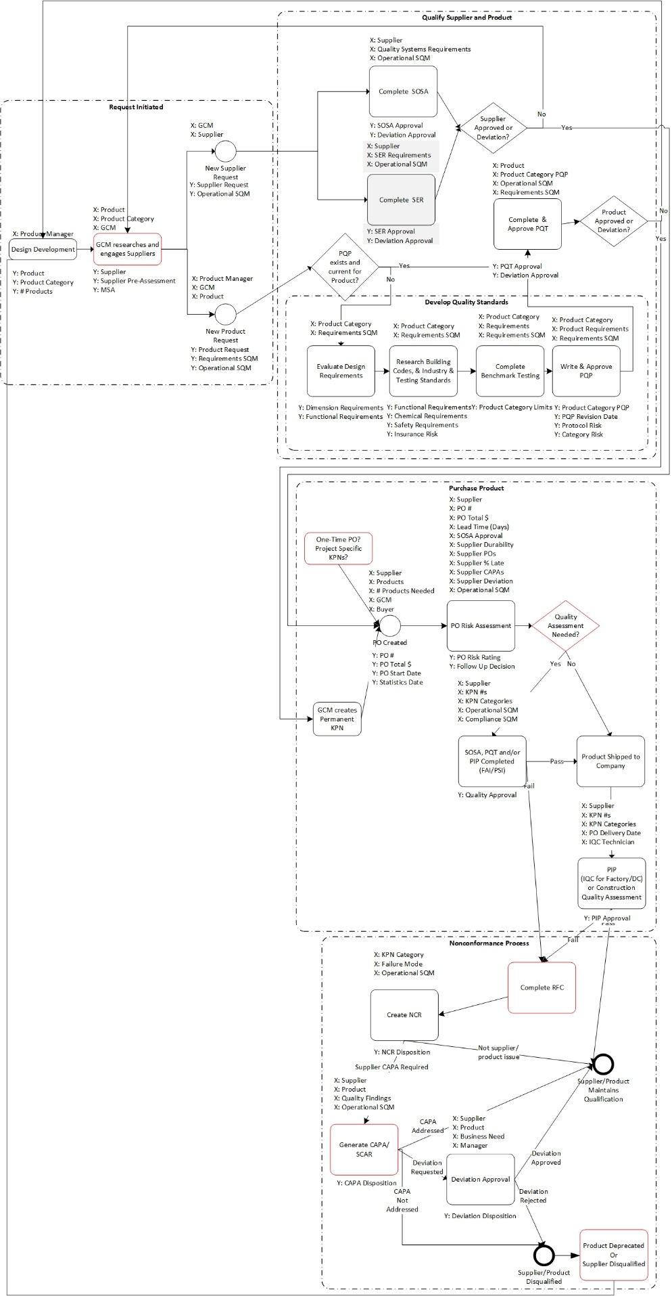

I summarized the analysis and reviewed it in detail with our ASQ-certified quality engineer. He is developing detailed process capability measures. Then, I held a meeting with the SQM team to review the process flow again to find specific pain points (Figure 1) and approve the rating scales. Additional projects were identified, including:

* Revise the supplier quality manual and create a knowledge base for daily SQM work instructions.
* Unify the Americas and Asia SQM processes into a single global process flow.
* Develop standard responses to known quality assessment failures.
* Automate requirements management and protocol risk.
* Work with GCM and other groups to ensure that SQM is engaged early in the supplier and product decision process and to ensure that disqualified suppliers and products cannot be used or ordered.

I also contacted IT to determine which enterprise systems would be available for reporting, and discussed quality tracking and reporting systems with Global Corporate Quality. Microsoft Excel, SAP Lumira, Power BI and Tableau were considered for reporting. Microsoft Excel and Power BI have similar query capabilities, but Power BI has a better interface for incorporating and managing data relationally, as well as better options for sharing reports. SAP Lumira had been the standard enterprise solution for business intelligence, but it was in the process of being replaced with either Power BI Pro or Tableau as the standard for dashboards. Because the Tableau license was not available and a Power BI Pro trial was available, Power BI Pro was chosen as the reporting solution for this project. I also created a database schema and discussed the SQM reporting needs with IT. The Power BI Pro trial has since expired and IT is working with me to transfer the data connections to Tableau, so that the reports can be recreated there and shared.

# Design

The system design began with the creation of the data collection interface as described in Measurement. In addition to establishing the data collection interface, I created alerts to notify the Americas SQM Team in the Scottsdale office when SQM requests were entered or their status updated, the primary customer is also notified, and PIPs entered by factory technicians fail. When a PIP fails, the Operational SQM responsible for the product category investigates to determine what happened and if the supplier should be contacted.

I created operational reports and an executive dashboard in Power BI, including web and mobile interfaces. I held meetings to review the operational reports with the Americas and Asia SQM teams, and with the SQM Director to review the operational reports and dashboard. The SQM Director approved the dashboard and demonstrated it to executive management. The data from the dashboard has been incorporated into the monthly reports to executive management.

The Americas SQM team agreed to review the Supplier and PO risk Assessment reports daily. They met with the SQM Director and established guidelines for responding to the different risk levels. High risk POs are immediately investigated to determine if a pre-shipment inspection can be done, and if it is warranted. Often POs are high risk because the PO was placed with a supplier that has not been qualified and/or the delivery has been completed. If needed, the Operational SQM works with the GCM to determine if the supplier is going to continue to be used, and if so, contacts the supplier to schedule an on-site assessment and discuss the product qualification process. High risk suppliers are evaluated together with GCM to determine if they should be disqualified. If we expect to continue business with a high-risk supplier, a plan is created for how to work with the supplier to improve their performance and/or quality systems.

# Validation

After the first quarter of 2018, I led a risk assessment workshop with the Americas team, including the SQM Director, to discuss the risk ratings. Each of the scales was discussed in detail. We decided to exclude one supplier as an outlier because they have much higher PO volume than most of the other suppliers from consideration in the distributions, and reevaluated the cutoffs for the ratings. We added an additional rating for deviations, rather than including the deviation risk in SOSA risk, which allows the supplier deviations and product deviations to be considered separately from supplier assessments. Most of the risk ratings were adjusted to smaller ranges due to reduced variation. More suppliers were identified as high risk for investigation as continuous improvement in supplier quality. I also thanked the team for their continued participation and feedback.

Because of the project, we have a clearer and more unified understanding of the Supplier Quality Management process. We have much greater visibility into how our suppliers and their products are performing and can share it more effectively with other teams and executive management. We quickly identify suppliers that are being used that have not been qualified and have greater engagement with Global Category Management. Short term projects that have been spawned from this effort include establishing SQM process capability measures, defining the process for disqualifying suppliers and products, revising the supplier quality manual, building a knowledge base for supplier quality management, unifying the Americas and Asia SQM team processes, and migrating SQM reports to a more efficient platform. We are also working on improving our engagement with other quality teams. Future planned improvements include building a response flow system for standard responses to inspection failures, and integrating our data collection into SAP HANA to build an application for the SQM process that integrates standards and requirements tracking with supplier and product evaluation, and provides automated data validation.